UNIVERSITY OF BUEA

COLLEGE OF TECHNOLOGY

REPUBCLIC OF CAMEROON

PEACE-WORK-FATHERLAND



**TOPIC: A WEB PLATFORM FOR CONNECTING SMALL BUSINESSES TO INVESTMENT AND FUNDING OPPORTUNITIES TO HELP THEM GROW AND EXPAND.**

DEPARTMENT OF COMPUTER ENGINEERING

BY

FRI SHARON MOFOR **CT20A094**

AJONGLEFAC E. TREVOR **CT21A010**

NADINE ABLA EJOH **CT21A091**

ACADEMIC SUPERVISOR

DR MELINGUI M. ROBERT

**ACADEMIC YEAR 2022-2023**

**Executive Summary**

This report outlines the development and implementation of "Business Boost," a web platform created as a school project to connect small and medium-sized enterprises (SMEs) with investment and funding opportunities. The primary objective of Business Boost is to address the funding challenges faced by SMEs, as they play a crucial role in driving the economy but often struggle to secure adequate capital for growth.

The implementation of Business Boost involved the design and development of a user-friendly interface where SMEs can create profiles, present their business plans, and outline their financial requirements. Additionally, the platform features a curated pool of potential investors actively seeking investment opportunities in the SME sector. The aim is to facilitate meaningful connections and mutually beneficial partnerships.

While this project is a school-based initiative, it demonstrates a practical and innovative solution to address the funding challenges faced by SMEs. Business Boost has the potential to empower SMEs by providing them with a platform to access the funding needed for expansion, job creation, and overall economic growth.

In conclusion, Business Boost represents an important step in connecting SMEs with investment and funding opportunities. By offering a dedicated web platform, it aims to bridge the funding gap and support the growth and success of SMEs. The report concludes with recommendations for further enhancements and improvements to maximize the impact of Business Boost in facilitating SME growth and contributing to economic development.

**Table of Contents**

Executive Summary ii

CHAPTER I: PROJECT OVERVIEW 4

1.1 Introduction 4

1.2 Problem Statement 5

1.3 Methodology 6

INCOME GENERATION 7

• Publishing adverts on the website 7

• Subscription fee for premium features 7

• Fee to view paid internships 7

CHAPTER II: ANALYSIS 8

2.1 Class diagram of the system 8

2.2 Use Case Diagram of the system 9

CHAPTER III: DESIGN AND IMPLEMENTATION 9

3.1 User interface design 9

CONCLUSION 13

REFERENCES 14

**CHAPTER I: PROJECT OVERVIEW**

* 1. **Introduction**

Brytzone is a web-based educational platform tailored for African University students, and is focused on helping them stay up-to-date with the latest information in their faculty/school, finding internships, participating in polls to better their academics and most importantly giving them enough exposure to via projects possibly land a job before leaving the university.

* 1. **Problem Statement**

Develop a comprehensive educational platform that addresses the following challenges faced by lecturers and students:

**Lack of visibility into student performance:** Provide lecturers with a tool to easily identify and analyze areas where students are struggling or performing poorly within their courses. This will enable timely interventions and personalized support to improve student learning outcomes.

**Limited access to internship opportunities:** Create a centralized platform that connects students with a wide range of internship opportunities offered by various companies. This platform should provide up-to-date information on available internships, requirements, application processes, and facilitate smooth communication between students and companies.

**Scarcity of reliable information sources:** Establish a reliable and trustworthy source of information for students, addressing the gaps in accessing relevant educational resources, updates, and announcements. This will help students stay informed and engaged with the latest information related to their courses, faculty, and university events.

**Bridging the gap between skilled students and job opportunities:** Provide a platform that offers exposure and networking opportunities for talented students. By connecting them with industry professionals, mentors, and potential employers, this platform will increase their chances of finding suitable job opportunities and enhance their career prospects upon graduation.

The proposed solution aims to empower lecturers and students by improving academic monitoring, facilitating internship discovery, ensuring access to reliable information, and fostering connections between skilled students and employment opportunities.

* 1. **Methodology**

**Data Analytics and Visualization:**

Implement data analytics techniques to analyze student performance data and identify areas where students are struggling or performing poorly within their courses.

Develop visualizations and reports that provide lecturers with actionable insights to help them understand the specific challenges and implement targeted interventions for improved learning outcomes.

**Internship Aggregation and Matching:**

Create a platform that aggregates internship opportunities from various companies and organizations.

Implement a matching algorithm that considers students' skills, qualifications, and preferences to connect them with relevant internship opportunities.

Enable seamless communication and application processes between students and companies through the platform.

**Content Curation and Information Dissemination:**

Curate relevant educational resources, updates, announcements, and event information from various sources.

Develop a user-friendly interface to present the information to students in an organized and easily accessible manner.

Implement features like notifications, personalized recommendations, and search functionality to ensure students have access to the latest and most relevant information.

**Networking and Industry Engagement:**

Establish partnerships with industry professionals, companies, and mentors to provide students with networking and mentorship opportunities.

Organize events, workshops, and seminars that bring students and professionals together, facilitating knowledge sharing and career development.

Develop a platform that allows students to showcase their skills, projects, and achievements to attract potential employers and increase exposure.

**Feedback Mechanisms and Continuous Improvement:**

Incorporate feedback mechanisms such as surveys, polls, and ratings to gather insights from lecturers and students.

Continuously assess the effectiveness of the platform's features and functionalities and make iterative improvements based on user feedback and changing needs.

**INCOME GENERATION**

**• Publishing adverts on the website**

**• Subscription fee for premium features**

**• Fee to view paid internships**

**CHAPTER II: ANALYSIS**

This chapter is all about analyzing the software development process, which is a crucial step for creating successful software. We will be looking at important things like software methodology, use case diagrams, and software architecture. By carefully analyzing these aspects, our goal is to fully understand the requirements of the system and make sure our software solution meets the needs of everyone involved.

2.1 **Class diagram of the system**

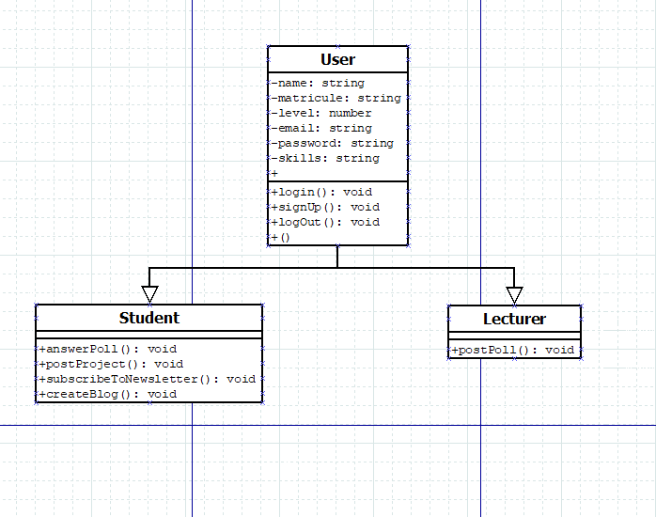

Fig 1.0 *BRYTZONE CLASS DIAGRAM*

* 1. **Use Case Diagram of the system**

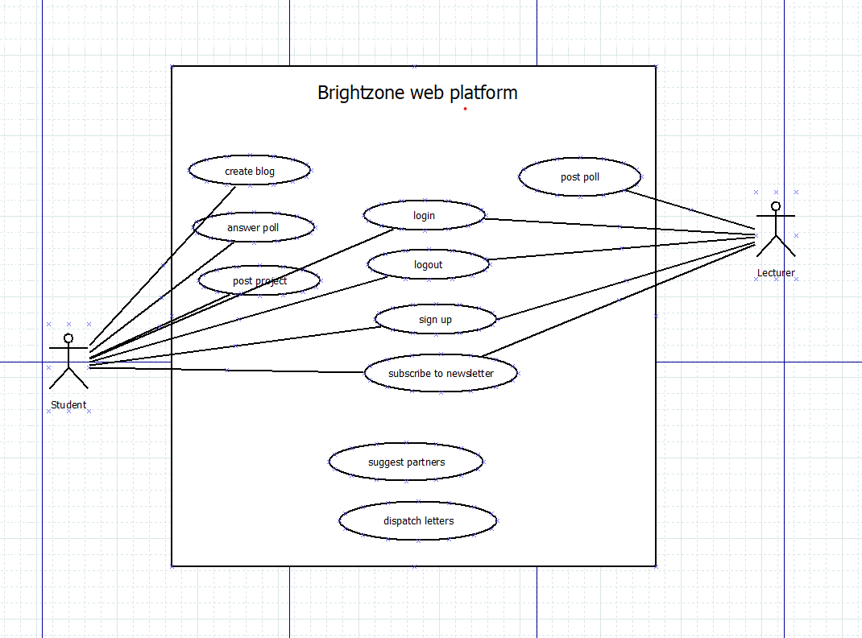

Fig 1.1 *BRYTZONE USE CASE DIAGRAM*

**Mongo DB**

**Node**

**CHAPTER III: DESIGN AND IMPLEMENTATION**

* 1. **User interface design**

Below is a screenshot of the UI designs done on Figma.

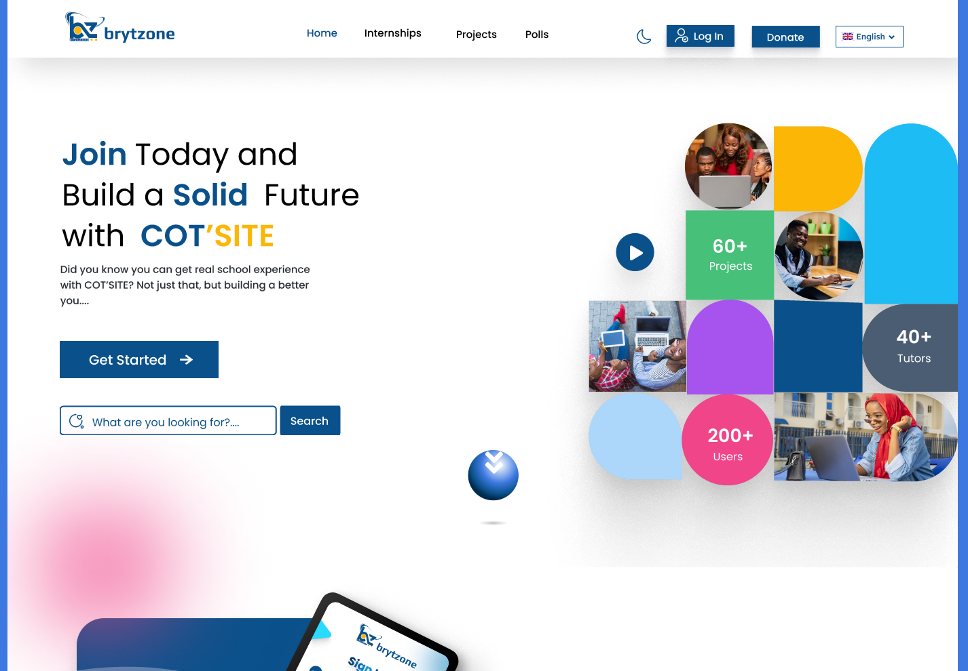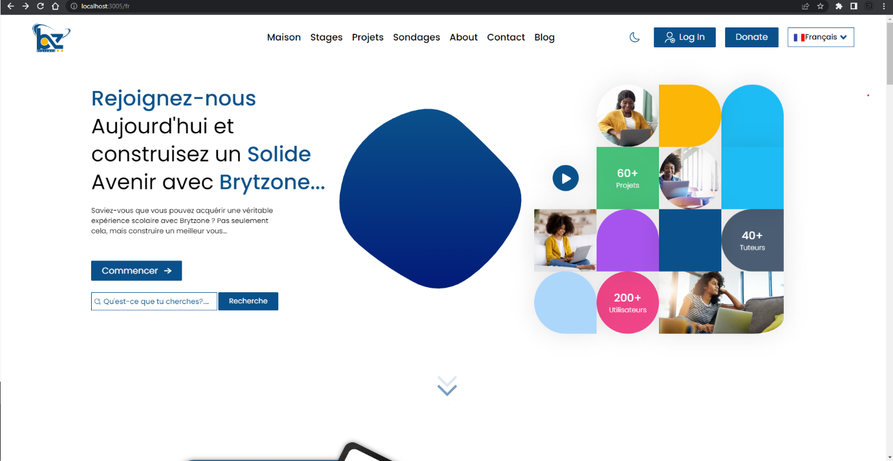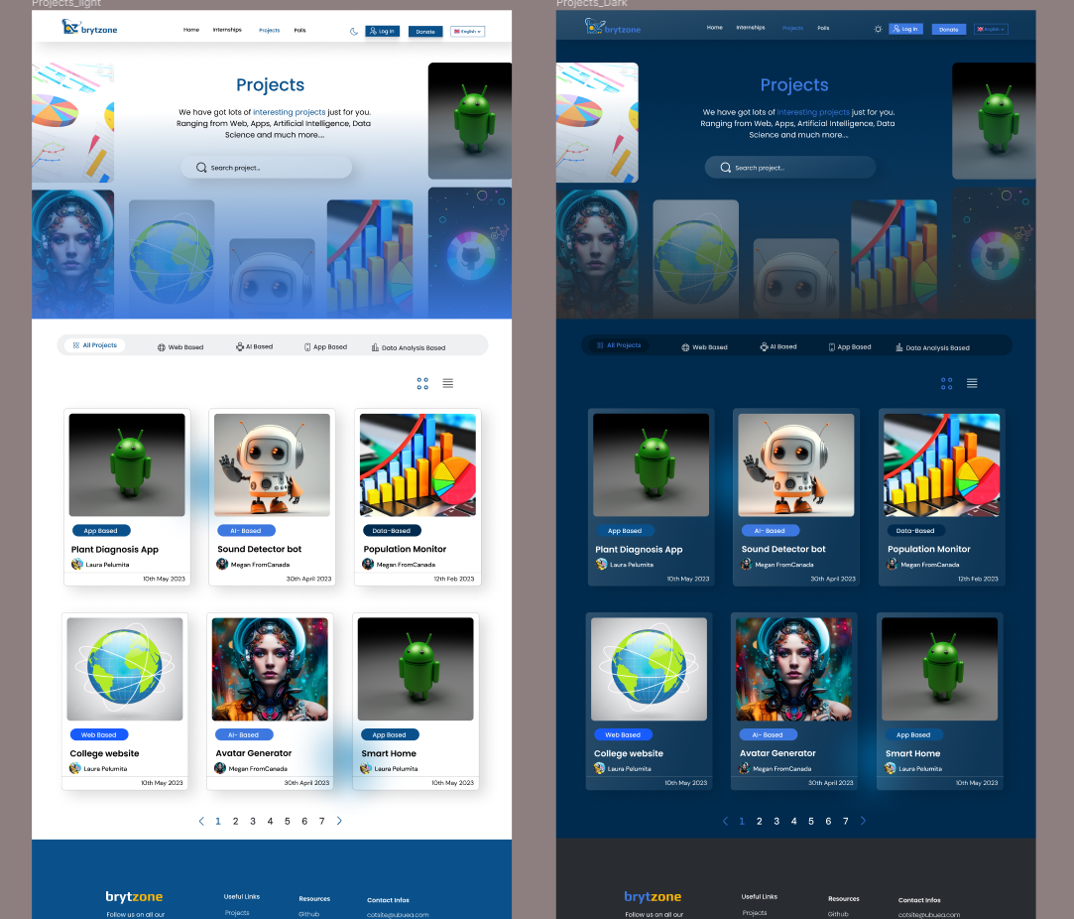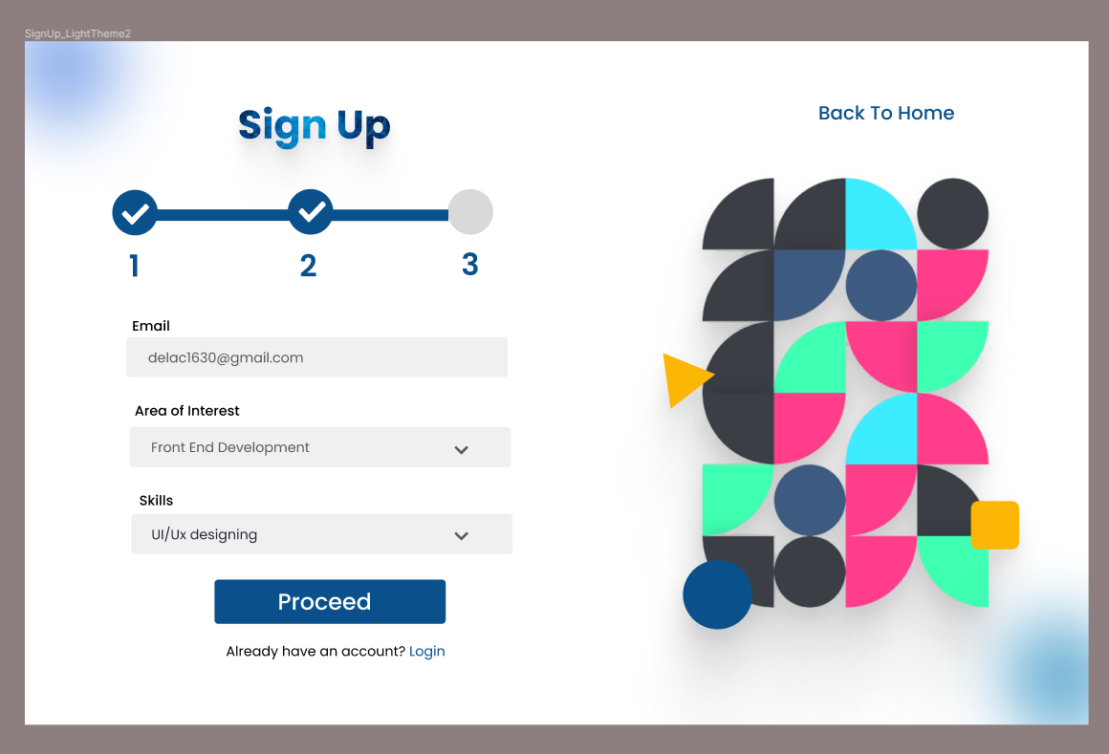

*Figure 3.1 UI designs on Figma*

**CONCLUSION**

* For this system to be correctly established, the school or faculty in question must accept to lend a hand in running the affairs.
* This project would greatly boost student’s overall academic experience.

**REFERENCES**

1. **Wikipedia.** Wikipedia. *Wikipedia.* [Online] 03 25, 2023. [Cited: 06 07, 2023.] https://en.wikipedia.org/wiki/Systems_architecture.

2. **Tech Target.** techtarget. [Online] 03 17, 2022. [Cited: 06 07, 2023.] https://www.techtarget.com/searchapparchitecture/definition/RESTful-API.

3. **Axios.** Axios. [Online] 08 19, 2020. [Cited: 06 07, 2023.] https://axios-http.com/.